# Exercises: Buy and Send Tokens to Someone

In this exercise we will play with **ERC20 tokens**. We shall unlock our wallet software, send transactions, watch the transaction processing and buy, sell and send/receive crypto-tokens (ERC20 tokens).

For this exercise we shall use Web-based crypto-wallet software called **MyEtherWallet** (**MEW**), which behaves like locally installed Ethereum crypto wallets, but is accessible through the Web, without any installation.

* MyEtherWallet is a **client-side wallet software**. It does not store your private keys, neither sends them at the server-side. Keeping your keys is a secure place is your obligation.
* MEW connects to the Ethereum blockchain through **REST API** (using client-side AJAX calls from JavaScript). The MyEtherWallet API is officially documented here: <https://www.myetherapi.com>.
* You can create / export / import **wallet keys**, sign and **send transactions** and **browse the blockchain**.
* MEW works with the **main** (production) Ethereum network, as well as with testing networks (**testnets**) like Ropsten, Kovan and Rinkeby.

## Buy ERC20 Tokens

The next thing to do is to buy some **ERC20 tokens**.

**Tokens** are digital assets hold in a **smart contract**. Typically, **token sale events** (also wrongly known as ICO) sale tokens to people who send ETH and get some tokens in the contract. Most token sale events use the [ERC20 token standard](https://theethereum.wiki/w/index.php/ERC20_Token_Standard) in their token sale smart contracts.

Note that **tokens are different than coins**:

* **Coins** (like Bitcoin, Ethereum and Dash) are digital currency assets hold by network accounts. Coin balances are stored in network addresses.
* **Tokens** (like Augur and EOS) are balances stored in a certain smart contract for certain network address. Token operations (like send and receive tokens) are done through the contract address.

Let’s get some tokens now.

1. Go to **“Contracts”** tab.
2. You can add the contract address and ABI/JSON Interface or select it from the drop-down menu from right.

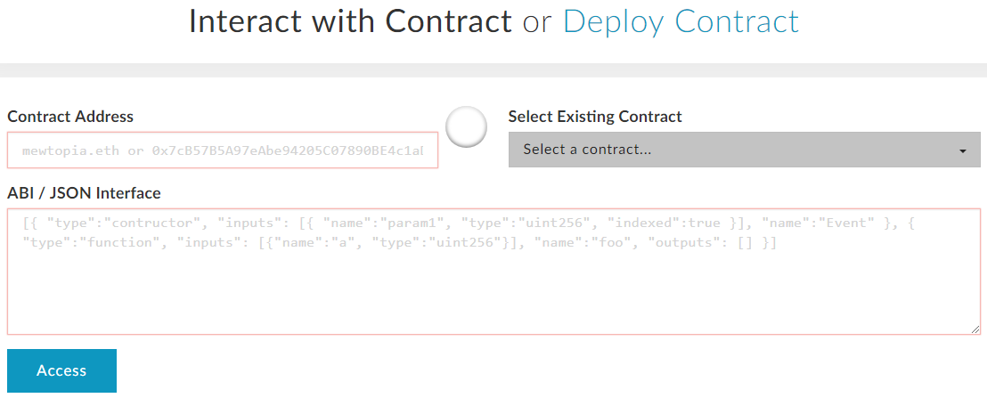

1. We will select from the drop-down menu and access it:

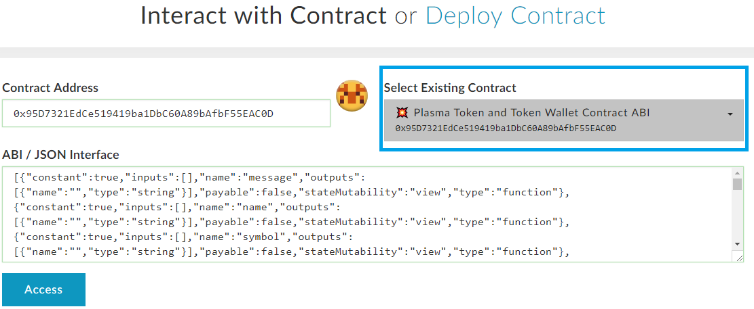

1. Now you will see the functions of the contract and select the **“buyTokenPay”** to buy tokens from the contract and click **Write**.

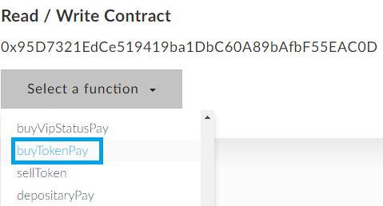

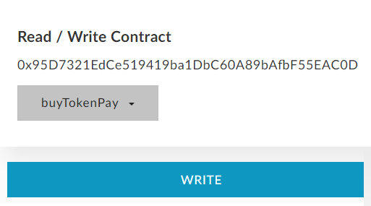

1. Write **1 ether** for amount to send. The **Gas Limit** is calculated automatically. You can write it manually and **Generate Transaction**. Then click **“Yes, I am sure! Make transaction”**

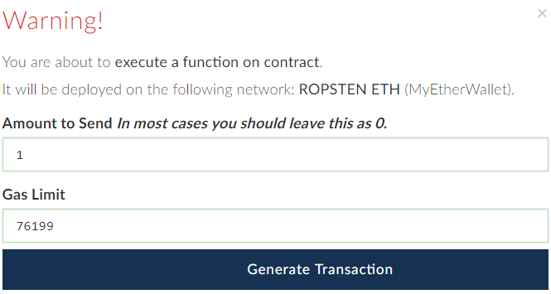

1. Now go to view your wallet info. Click “**Load Tokens**” (you can add the tokens by yourself by clicking “Add Custom Token”).

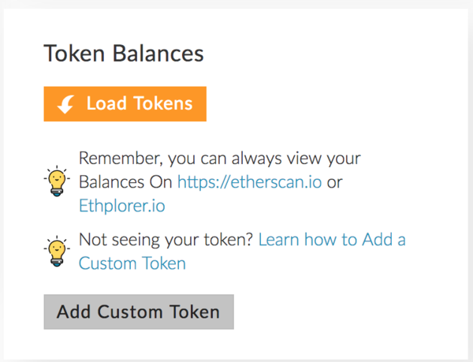

1. You will see the tokens you’ve bought:

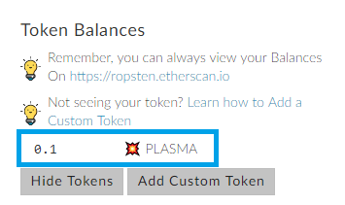

Congrats, now you have 0.1 PLASMA tokens!

## Send Tokens to Another Address

1. Get someone’s address from the class and send him/her 0.05 PLASMA tokens.
2. Go to the **“Send Ethers & Tokens”** tab and unlock your account with the **JSON file**. Put the **address** of your mate and the **amount** you want to send. The **Gas Limit** is the default one. Generate the transaction. Then click **Send Transaction.**
3. Click **“Load Tokens”** to see the PLASMA token.

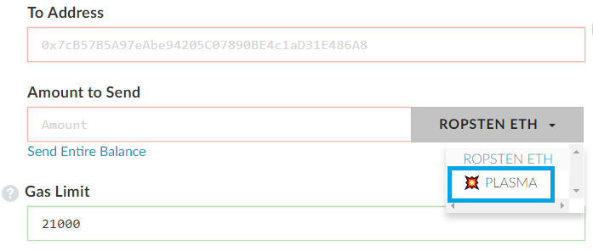

1. Do the same step from **exercise 3**. Sending tokens is like sending ethers.

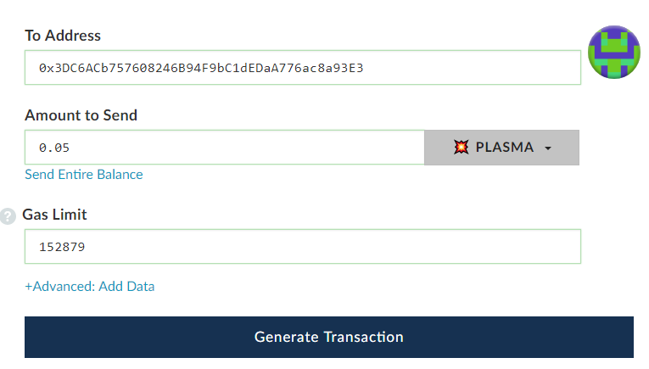

1. Go to the wallet info and you should have 0.05 PLASMA tokens, if everything was successful.

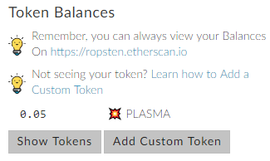

Congrats, you’ve send 0.05 PLASMA tokens to your mate!

# What to Submit?

Submit as exercise outcome the **URL of your Ethereum address** in the Ropsten network at EtherScan, e.g.:

* <https://ropsten.etherscan.io/address/0xb97e993872a903850c07fbd999a6e750963ef195>

You should some **tokens** in your balance, as well as some transaction history of token transfers. Examples:

